Lab 8

Configuring DNS Zones

This lab contains the following exercises and activities:

|  |  |
| --- | --- |
| Exercise 8.1 | Installing DNS |
| Exercise 8.2 | Creating Primary and Secondary Zones |
| Exercise 8.3 | Creating an Active Directory Integrated Zone |
| Exercise 8.4 | Configuring Zone Delegation |
| Exercise 8.5 | Configuring a Stub Zone |
| Exercise 8.6 | Configuring Forwarding and Conditional Forwarding Zones |
| Exercise 8.7 | Configuring Zone Transfers |
| Lab Challenge | Using the DNSCMD Command To Manage Zones |

BEFORE YOU BEGIN

The lab environment consists of student workstations connected to a local area network, along with a server that functions as the domain controller for a domain called *contoso.com*. The computers required for this lab are listed in Table 8-1.

Table 8-1

Computers Required for Lab 8

|  |  |  |
| --- | --- | --- |
| Computer | Operating System | Computer Name |
| Server (VM 1) | Windows Server 2012 | RWDC01 |
| Server (VM 2) | Windows Server 2012 | Server01 |

In addition to the computers, you also require the software listed in Table 8-2 to complete Lab 8.

Table 8-2

Software Required for Lab 8

|  |  |
| --- | --- |
| Software | Location |
| Lab 8 student worksheet | Lab08_worksheet.rtf (provided by instructor) |

Working with Lab Worksheets

Each lab in this manual requires that you answer questions, take screen shots, and perform other activities that you will document in a worksheet named for the lab, such as Lab08_worksheet.rtf. You will find these worksheets on the book companion site. It is recommended that you use a USB flash drive to store your worksheets, so you can submit them to your instructor for review. As you perform the exercises in each lab, open the appropriate worksheet file using WordPad, fill in the required information, and save the file to your flash drive.

After completing this lab, you will be able to:

* Configure DNS zones including primary zones, secondary zones, and Active Directory Integrated zones.
* Configure Zone delegation
* Configure a Stub Zone
* Configure Forwarding and Conditional Forwarding zones
* Configure Zone Transfers
* Use DNSCMD command to manage zones

Estimated lab time: 80 minutes

|  |  |
| --- | --- |
| Exercise 8.1 | Installing DNS |
| Overview | In Lesson 1, you already installed DNS on RWDC01. However, we need a second DNS server for future exercises. Therefore, during this exercise, you install a second DNS server on Server01. |
| Completion time | 10 minutes |

**1.** Log in to Server01 as the **Contoso\administrator** user account with the Password **Password01**. The Server Manager console opens.

**2.** When Server Manager opens, select Manage and click Add Roles and Features.

**3.** On the Before you begin page, click Next.

**4.** Select *Role-based or feature-based installation*, and then click Next.

**5.** Click *Select a server from the server pool*, click Server01.contoso.com, and then click Next.

**6.** On the Select server roles page, click DNS Server.

**7.** When the Add Roles and Features Wizard dialog box appears, select Add Features, and then click Next.

**8.** When the Select features page opens, click Next.

**9.** On the DNS Server page, click Next.

**10.** On the Confirm installation selections page, click the Install button.

**11.** When the installation is done, click the Close button.

End of exercise. You can leave the windows open for the next exercise.

|  |  |
| --- | --- |
| Exercise 8.2 | Creating Primary and Secondary Zones |
| Overview | During this exercise, you create primary and secondary zones on RWDC01 and Server01. |
| Completion time | 15 minutes |

**Mindset Question: For the Contoso Corporation, you are building a new network. Therefore, you need to install DNS to support your network. You have three primary sites. So how many primary zones and how many secondary zones would you create to support the primary site?**

# Creating a Standard Forward Lookup Primary Zone

**1.** Log in to RWDC01 as the **Contoso\administrator** user account with the Password **Password01**. The Server Manager console opens.

**2.** On Server Manager, click Tools > DNS to open the DNS Manager console. If necessary, expand the DNS Manager console to a full-screen view.

|  |  |
| --- | --- |
| Question 1 | What is the primary tool to manage DNS in Windows? |

**3.** Expand the server so that you can see the Forward Lookup Zones and Reverse Lookup Zones folders, if needed.

**4.** Click, then right-click Forward Lookup Zones, and then click New Zone.

**5.** When the Welcome to the New Zone Wizard page opens, click Next.

**6.** On the Zone Type page (as shown in Figure 8-1), with the Primary zone radio button already selected, click to deselect the Store the zone in Active Directory option. Click Next.

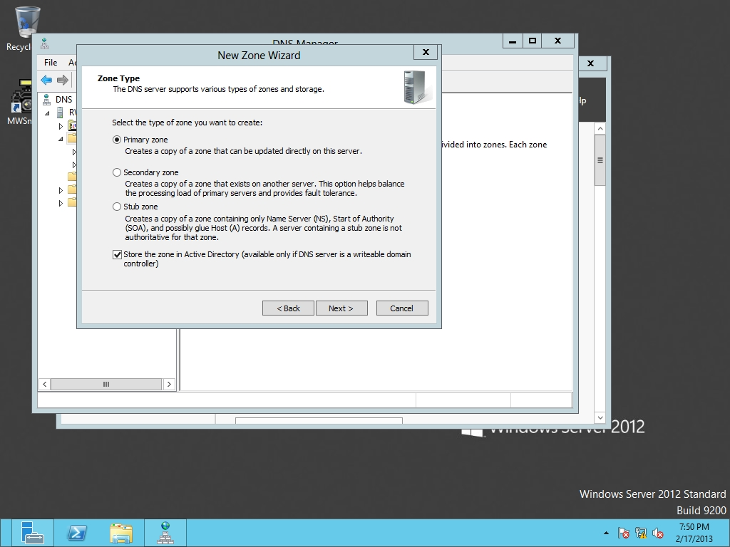

Figure 8-1

Creating a new zone

**7.** The Zone Name page opens. In the Zone name text box, type **adatum.com**, and then click Next.

**8.** On the Zone File page, ensure that the *Create a new file with this file name* radio button is selected, and then click Next.

**9.** On the Dynamic Update page, ensure that the *Do not allow dynamic updates radio button* is selected, and then click Next.

**10.** When the Completing the New Zone Wizard page displays, click Finish.

# Creating a Standard Forward Lookup Secondary Zone

**1.** On Server01, click Tools > DNS to open the DNS Manager console. If necessary, expand the DNS Manager console to a full-screen view.

**2.** Expand the server so that you can see the Forward Lookup Zones and Reverse Lookup Zones folders, if needed.

**3.** Click, then right-click Forward Lookup Zones, and then click New Zone.

**4.** When the Welcome to the New Zone Wizard page opens, click Next.

**5.** On the Zone Type page, select the Secondary zone radio button and click Next. The Zone Name page appears.

**6.** In the Zone name text box, type **adatum.com**, and then click Next.

**7.** On the Master DNS Servers page, type **192.168.1.50** (as shown in Figure 8-2) and then press the Enter key. Click Next.

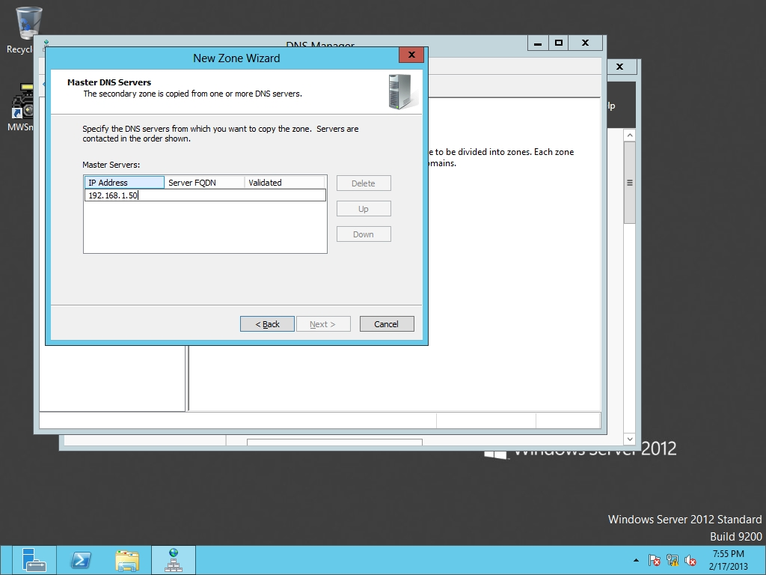

Figure 8-2

Specifying the master DNS server

**8.** When the Completing the New Zone Wizard page opens, click Finish.

# Creating a Standard Reverse Lookup Primary Zone

**1.** On RWDC01, go to the DNS Manager console. Right-click Reverse Lookup Zones, and then click New Zone.

**2.** When the Welcome to the New Zone Wizard page opens, click Next.

**3.** On the Zone Type page (as shown in Figure 8-3), click Next.

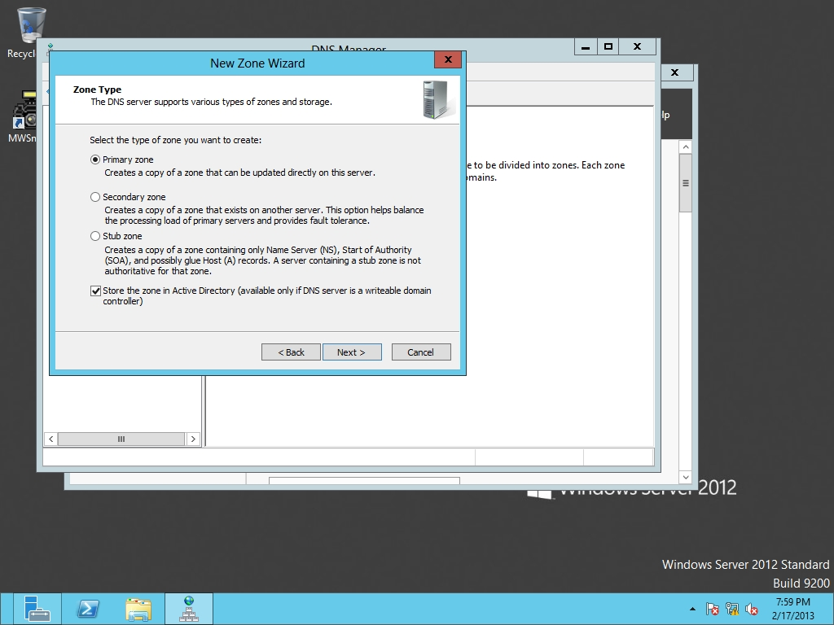

Figure 8-3

Specifying the zone type

**4.** On the Active Directory Zone Replication Scope, click Next.

**5.** On the Reverse Lookup Zone Name page, with IPv4 Reverse Lookup Zone already selected, click Next.

**6.** Type in the network address of **172.24.1**. Click Next.

**7.** On the Dynamic Update page, click Next.

**8.** When the Completing the New Zone Wizard page opens, click Finish.

End of exercise. You can leave the windows open for the next exercise.

|  |  |
| --- | --- |
| Exercise 8.3 | Creating an Active Directory Integrated Zone |
| Overview | During this exercise, you create an Active Directory Integrated zone. |
| Completion time | 5 minutes |

**Mindset Question: You decide that you want to improve the DNS system for your company and you are thinking of switching to Active Directory-Integrated zones. What are the advantages of Active Directory-Integrated zones?**

**1.** On RWDC01, go to the DNS Manager console.

**2.** Right-click the Forward Lookup Zones and click New Zone.

**3.** When the New Zone Wizard starts, click Next.

**4.** With Primary zone and Store the zone in Active Directory options are already selected, click Next.

**5.** On the Active Directory Zone Replication Scope dialog box, click Next.

**6.** On the Zone Name page, type **fabrikam.com** and click Next.

**7.** On the Dynamic Update page, with the *Allow only secure dynamic updates* selected, click Next.

|  |  |
| --- | --- |
| Question 2 | What is needed to perform secure dynamic updates? |

**8.** Click Finish. The fabrikam.com domain is created.

End of exercise. You can leave the windows open for the next exercise.

|  |  |
| --- | --- |
| Exercise 8.4 | Configuring Zone Delegation |
| Overview | In this exercise, you delegate a subdomain called *support under fabrikam.com* on a different DNS server. |
| Completion time | 5 minutes |

**Mindset Question: You are working for the Contoso Corporation. Why would you want to use zone delegation and conditional forwarding?**

**1.** On RWDC01, go to the DNS Manager console. Under Forward Lookup Zones, click and right-click Fabrikam.com and click New Delegation.

**2.** When the Welcome to the New Delegation Wizard starts, click Next.

**3.** In the Delegated domain text box, type **support** (as shown in Figure 8-4) and then click Next.

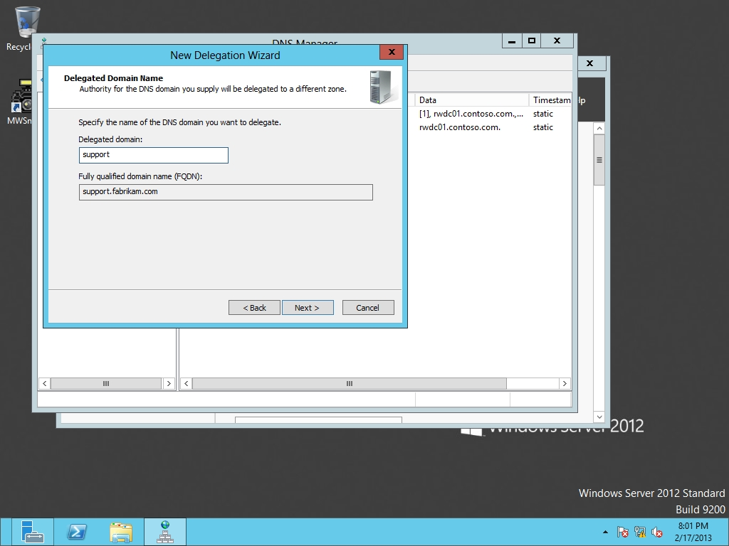

Figure 8-4

Delegating a domain

**4.** On the Name Servers page, click the Add button, type **Server01** in the *Server fully qualified domain name (FQDN)* text box, and click Resolve. Don’t worry about the red circle with the white X; the zone in Server01 still needs to be created. Click the OK button to close the New Name Server Record dialog box. Click Next.

**5.** When the wizard is complete, click the Finish button.

**6.** On Server01, go to the DNS Manager console. Right-click Forward Lookup Zones, and click New Zone.

**7.** When the New Zone Wizard starts, click Next.

**8.** On the Zone type, with the Primary zone already selected, click Next.

**9.** On the Zone Name page, type **support.fabrikam.com** in the Zone name text box and click Next.

**10.** On the Zone File page, click Next.

**11.** On the Dynamic Update page, click Next.

**12.** When the wizard is complete, click Finish.

End of exercise. You can leave the windows open for the next exercise.

|  |  |
| --- | --- |
| Exercise 8.5 | Creating a Stub Zone |
| Overview | In this exercise, you create a stub zone that points directly to another DNS server. |
| Completion time | 10 minutes |

**Mindset Questions: What resource records are found in the stub zone?**

**1.** On RWDC01, go to the DNS Manager console. Right-click Forward Lookup Zones, and click New Zone.

**2.** When the New Zone Wizard begins, click Next.

**3.** When the Zone Type page opens, select the Stub zone radio button and click Next.

**4.** On the Active Directory Zone Replication Scope page, click Next.

**5.** On the Zone Name page, type **litware.com** in the Zone name text box, and then click Next.

**6.** On the Master DNS Servers page, type **192.168.1.60** and press the Enter key. Click Next.

**7.** When the Completing the New Zone Wizard displays, click Finish.

**8.** On Server01, go to the DNS Manager console. Right-click Forward Lookup Zones and click New Zone.

**9.** When the New Zone Wizard, click Next.

**10.** On the Zone Type page, click Next.

**11.** On the Zone Name page, type **litware.com** and click Next.

**12.** On the Zone File page, click Next.

**13.** On the Dynamic Update page, click Next.

**14.** When the wizard is complete, click Finish.

**15.** Take a screen shot of the DNS Manager window by pressing Alt+Prt Scr and then paste it into your Lab08_worksheet file in the page provided by pressing Ctrl+V.

End of exercise. You can leave the windows open for the next exercise.

|  |  |
| --- | --- |
| Exercise 8.6 | Configuring Forwarding and Conditional Forwarding Zones |
| Overview | To improve performance, you can control which DNS servers requests are forwarded to when performing naming resolution by configuring forwarding and creating conditional forwarding zones. Therefore, during this exercise, you configure forwarding and create a conditional forwarding zone. |
| Completion time | 10 minutes |

# Configuring Forwarders

**1.** On Server01, go to the DNS Manager console. Right-click Server01 and select Properties. The Server Properties dialog box opens.

**2.** Select the Forwarders tab.

**3.** Click the Edit button. The Edit Forwarders dialog box opens as shown in Figure 8-5.

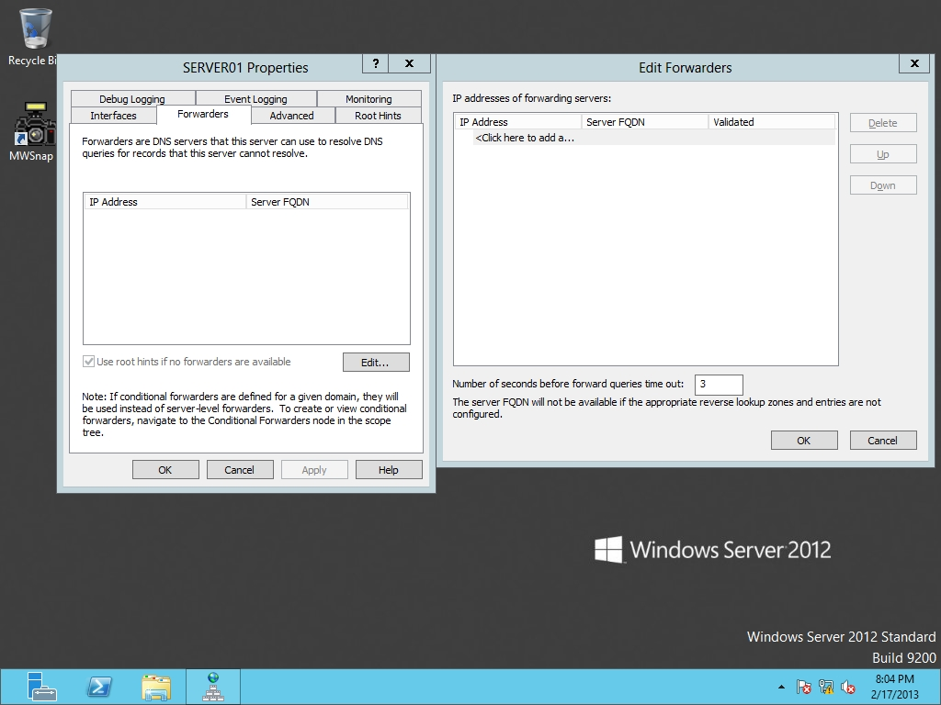

Figure 8-5

Specifying DNS servers to forward request to

**4.** In the IP address column, type **192.168.1.50** and press Enter. After validation, click the OK button to close the Edit Forwarders dialog box.

**5.** Click the OK button to close the server Properties dialog box.

# Configuring Conditional Forwarders

**1.** On Server01, use the DNS Manager console to create a primary lookup zone called **lucernepublishing.com**.

|  |  |
| --- | --- |
| Question 3 | How do you forward queries to a specific DNS server for a specified domain? |

**2.** On RWDC01, go to the DNS Manager console. Click Conditional Forwarders Zones. Right-click Conditional Forwarders Zones and click New Conditional Forwarder. The New Conditional Forwarder dialog box appears as shown in Figure 8-6.

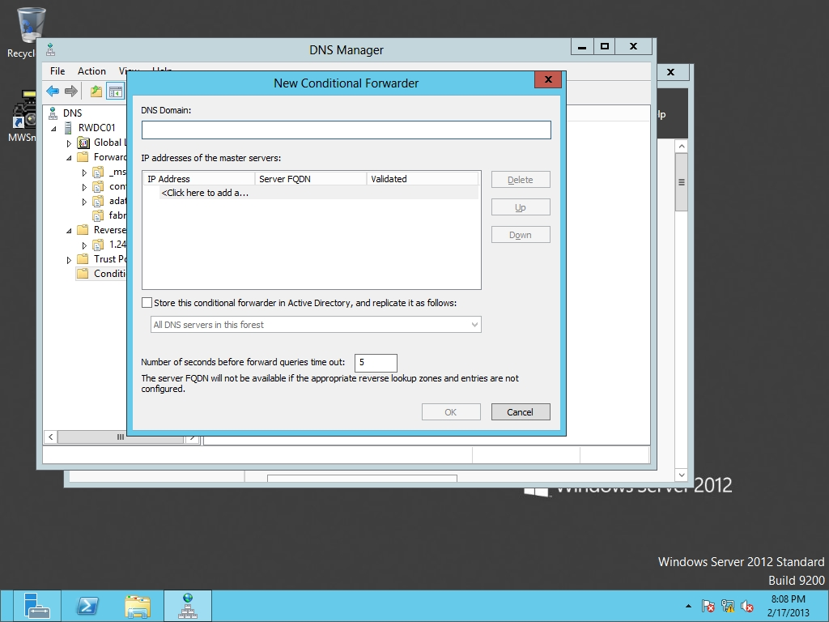

Figure 8-6

Creating a new conditional forwarder

**3.** Type **lucernepublishing.com** in the DNS Domain text box.

**4.** In the IP Address column, type **192.168.1.60** in the IP addresses column and press the Enterkey.

**5.** Click **OK** to close the New Conditional Forwarder dialog box.

End of exercise. You can leave the windows open for the next exercise.

|  |  |
| --- | --- |
| Exercise 8.7 | Configuring Zone Transfers |
| Overview | By configuring zone transfers, you can control which servers DNS information is copied. |
| Completion time | 10 minutes |

**Mindset Questions: You need to configure zone transfers between multiple DNS servers. What are the three types of zone transfer available?**

**1.** On RWDC01, using the DNS Manager console, click adatum.com and then right-click the adatum.com zone and click Properties. The Properties dialog box opens.

**2.** Click the Zone Transfers tab.

**3.** With the Allow zone transfers option already selected (as shown in Figure 8-7), select Only to the following servers.

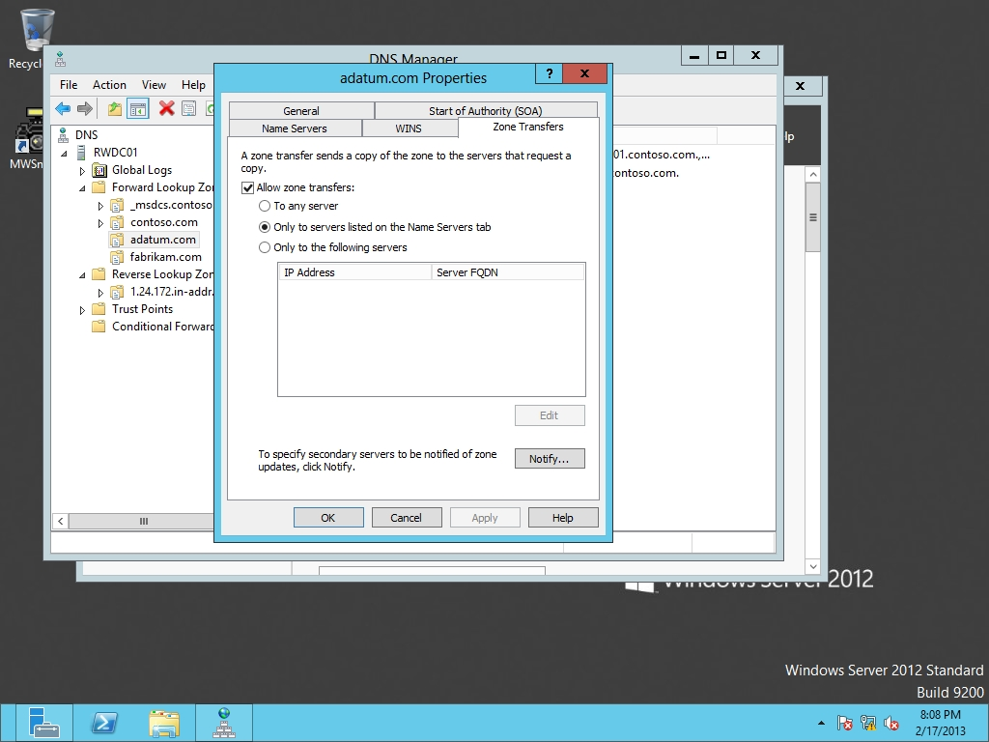

Figure 8-7

Configuring zone transfers

**4.** Click Notify, click The following servers, type **192.168.1.60** in the IP Address column, and press the Enter key. After validation, click OK.

**5.** Click OK to close the Properties dialog box.

Lab REview Questions

|  |  |
| --- | --- |
| **Completion time** | **10 minutes** |

**1.** In Exercise 8.2, what must you create before creating the secondary zone?

**2.** In Exercise 8.3, what is the prerequisite to have Active Directory-Integrated zones?

**3.** In Exercise 8.6, how do you configure all queries that a DNS server cannot directly resolve be forwarded to your ISP’s DNS server?

**4.** In Exercise 8.6, where did you configure forwarding?

**5.** In Exercise 8.7, how did you configure zone transfers?

|  |  |
| --- | --- |
| Lab Challenge | Using the DNSCMD Command to Manage Zones |
| Overview | To complete this challenge, you must demonstrate how to use the DNSCMD command to manage zones. |
| Completion time | 10 minutes |

You need to configure a few scripts that will create DNS zones. Therefore, what commands would you use to perform the following on RWDC01.contoso.com:

Create a primary zone called fabrikam.com

Create a secondary zone called *contoso.com*. The primary server is located at 192.168.1.60

Create an Active Directory integrated zone called litware.com

Delete a secondary zone called lucernpublishing.com.

Force a zone replication for the lucernpublishing.com zone.

End of lab. You can log off or start a different lab. If you want to restart this lab, you’ll need to click the End Lab button in order for the lab to be reset.